**Iphone Bayonet Mount** - Could be used for modular microcomputer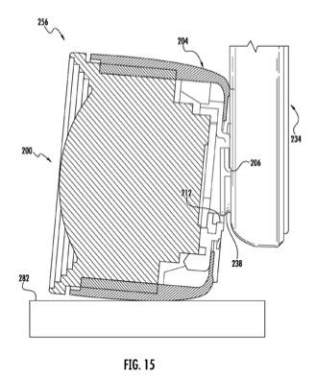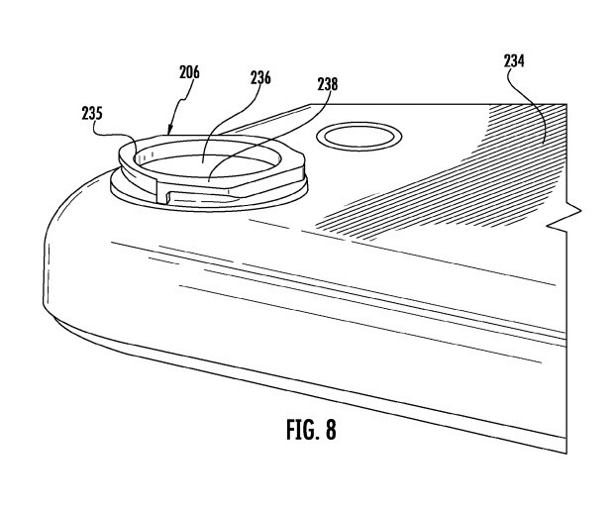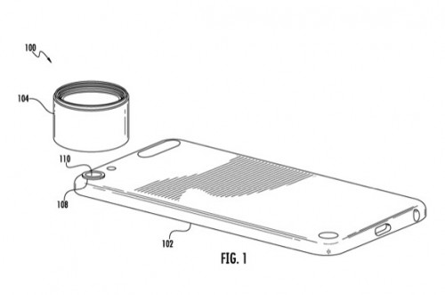

Basic Bayonet Mount Tutorial

<https://www.youtube.com/watch?v=3HjbG45fBGk>

Simple Bayonet Mounting

<https://www.youtube.com/watch?v=lg3-GDRpfuo>